A Proposed Rocket Propulsion System*

*A design developed by Team B - Saturn V

1st Angel Alain Sosa Rodr´ıguez 2nd An´ıbal Guerrero Hernandez´ 3rd Alejandro Lopez´ 4th Christian Racke
angel.sosa-rodriguez@tum.de anibal.guerrero@tum.de alejandro.lopez-nacher@tum.de christian.racke@tum.de

5th Ignacio Zu´niga˜ Mart´ınez
i.zuniga@tum.de

Abstract—This document describes a new proposed rocket propulsion system that utilizes a bi-propellant engine with liquid oxygen (LOX) as the oxidizer and liquefied methane (LCH4) as the fuel. The system has been designed to achieve missions to Low Earth Orbit (LEO), assuring the requirements and regulations of the European Space Agency (ESA) and with a payload capability of up to 5,000 kg in cumulative mass. Launching sites are evaluated and proposed within a scope of agreements and cooperations of the different space agencies. The report includes a detailed description of the engine’s design, the system’s key performance characteristics and operational parameters, the main propulsion system and subsystem, as well as the approaches with analysis and working logic. The results demonstrate the scope of the introduced propulsion system with a reliable and cost-effective solution for requested ESA and other customers missions.

Index Terms—Rocket, Propulsion, Gas generator, LEO, Bi propellant, LOX, LCH4

- INTRODUCTION

The global space economy is a rapidly growing industry, with a current valuation of over 423.8 billion U.S. dollars, and a projected CAGR of over 9% from 2020-2029 [weforum]. The major segments of the space economy include satellite services, space launch services, spacecraft, government expenditure, and space venture investment. While government-sponsored programs have traditionally dominated the space industry, private investment in space companies reached a record high of 8.9 billion USD in 2020 [aviationweek]. Launch costs have fallen significantly over the years due to advancements in technology, materials, and production methods, making it possible for new space applications and industries to emerge [csis].

The market for commercial space launches is expected to grow significantly due to increasing demand for satellite services, human spaceflight, lunar exploration, and interplanetary probes. The development of new technologies such as small satellites and reusable rockets is enabling more innovation and disruption in the space market while evolving customer demands are creating new opportunities and challenges for existing and new players.

Our rocket launcher start-up aims to solve high launch costs and limited competition in the space launch services market by offering an optimized first stage for a medium-sized rocket launcher. The launcher will have 3 stages and will carry an ESA payload as well as other commercial payloads from a wide range of services. After a detailed mission analysis, the main focus was designing the main stage, a liquid propulsion system that uses LOX/LCH4 gas generator. By providing a more cost-effective and efficient alternative to traditional rocket launch services, we aim to capture a significant share of the growing space launch market.

  - OVERVIEW OF THE PROPOSED LAUNCHER SYSTEM

- Payload capability (target orbits and their V require-ments vs. payload mass)

When deciding what payload capability the launcher must accommodate, all requirements must be met within the imposed limitations. The first limitation to consider is the cumulative mass of ESA mission payloads that must be launched to LEO, which is set at 5,000 kg. To select which mission is chosen, several criteria were taken into account.

The prospective rocket was to be launched as soon as possible, with 2023 being the earliest. In practice, this is unrealistic. The project starts at Phase 0, where a mission analysis and identification are performed, and ends in Phase B2/C, with a detailed definition. The project moves from adoption to implementation, where detailed designs are prepared. However, for the launcher to be operational (Phase E), Phase D must be passed. In this phase, a Qualification Model is built to verify system performance, and environmental testing is undergone. This stage alone can take more than two years. A total mission lifetime cycle typically lasts around a decade. If true time constraints were to be considered, not a single mission from the required could be launched. Therefore, immediate availability of the launcher is considered, meaning that launching in 2023 would be possible. Seven of the 13 ESA missions are expected to launch in 2023.

Of all the options, ESA’s Space Rider mission to LEO is the best option, as it has a mass of 4900kg. In consequence, the

launcher must accommodate Space Rider’s spacecraft within the fairing. Therefore, the fairing must have a minimum height and diameter of 9m and 3:3m respectively, corresponding to the Space Rider spacecraft’s dimensions [esa]. The launcher will have a diameter of 4m, providing sufficient space for the ESA payload and flexibility for additional missions. The fairing’s height will be later determined when deciding upon the fairing’s shape, which becomes relevant towards reducing aerodynamic losses in section IV-F.

The Table I shows the data from the Space Rider mission.
of mission failure on the first launches, which as a start-up, is considered vital. Second, and due to time constraints, as the development of boosters differs significantly from the main engine, serial staging allows focusing deeper on the development of the main engine of the first stage, which can later be adapted for uppers stages.

Before computing the mass budget of the rocket, a study of the number of stages has been performed. To do so, a comparison of the mass reduction for different stages comparison has been performed (Figure 1).

TABLE I: ESA missions

Mission | Payload [kg] | Orbit | Altitude [km] | Launch Year
Space Rider | 4900 | LEO | 400 | 2023

Additionally, further payload capabilities available and later missions after launching the ESA mission may be used to transport other commercial satellites. A table with some commercial satellite constellations with desired orbit LEO is included in Table ?? in Appendix ??.

B. Launcher V budget

In alignment with the Payload Selection and the market increase of small and medium satellites, which mostly perform their activities in LEO orbits, the main operation of the launcher would be the set up of these satellites in LEO orbits.

The estimation of the necessary V required has been calculated from historical values [Humble]. Conservative values have been selected for the first approach, to later obtain more approximated values by iteration (see section IV-F). The contributions to the total budget are the following (Table II):

V_{LEO}: Approximated ideal Kepler V of a circular low inclination LEO.
V_{grav}: Gravitational losses

V_{atm}: Atmospheric losses

V_{LEO}: Steering losses (Thrust misalignment & path correction)
V_{rot}: V gain due to Earth rotation (Kourou launch)

TABLE II: V contributions [m/s]
^{V}LEO | Vgrav | ^{V}ath | Vste | Vrot | V
7800 | 1800 | 100 | 80 | 463 | 9236

C. Launcher mass budget

The Launcher mass is heavily influenced by the stages and the architecture. A serial stage has been selected over a parallel/boosters architecture for two main reasons. First, in alignment with the market analysis and the viability of the launcher, the booster main-stage structural and joint-performance testing is way more complex, increasing the risk

Fig. 1: Comparison of launcher gross mass for different stages ( v=8000 m/s, PL=5000 kg).
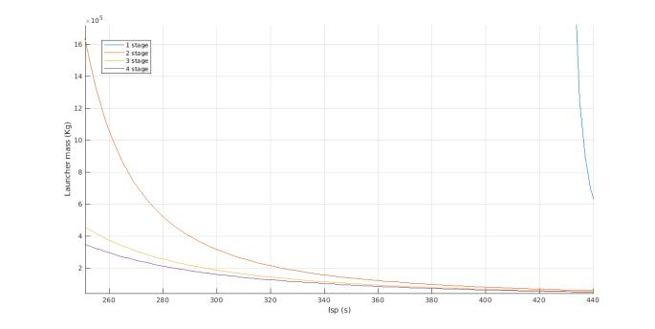

Since the Isp range of the propellants is between 300-350 s. We can observe that the reduction of mass in this area between two and three stages is significant ( 35%), but between three and four stages is only 7%. After considering the increase in the cost and complexity of adding a new stage, with the subsequent increment of failure probability, a sequential three-stage configuration has been selected. This three-stage configuration can also be quite beneficial for the flexibilization of the upper stage, helping to set satellites at specific orbits, and increasing the market opportunities. Additionally, the upper stage can be specifically designed with a space-adapted configuration, increasing the performance of the launcher significantly.

As the structural design is out of the scope of this project, and in alignment with the previous sections, a conservative approach has been followed for the selection of the structural ratio of the launcher. A structural ratio of _{str} = 0:15 has been selected for the three stages.

For the calculation of the optimum mass budget of each stage, a classical Lagrange multipliers optimization has been followed [curtis2013orbital]. The equations have been solved numerically. The first iterations made set the mass of the launcher around 250 tons and later were refined iterating over more accurate values of the losses and the specific impulse. The final budget is shown in Table III and corresponds to the budget after several iterations and is computed with the final

2

Isp values obtained from the engine (See section IV-F).

TABLE III: Weight budget comparison [Tons]

Isp=[322.61, 335.79, 335.79] (s), _{str} = 0:15

 | Stage 1 | Stage 2 | Stage 3
Gross mass | 270.92 | 71.6 | 18.92
Prop. mass | 169.43 | 44.77 | 11.83

D. Engine types, cycles, and propellants

As essential components of the proposed launcher system, the engine type, cycle, and propellant are subjected to a detailed analysis for its final selection. With the aim to have a well-balanced decision between technical advantages and cost efficiency, a trade-off of key performances such as ISP, re-ignitability, T/W ratio, among others, is being carried out as it can be seen in Appendix ?? Table ?? and in Table ??. Once relevant data is gathered, a grading system will be implemented (See appendix ?? Table ?? and Table ??) to finally select the components of the proposed launcher system. The selection process is at the same time constraint to the goal of a 5000 kg payload mass, meeting official regulations and staying within the scope of the market. For the engine type, a liquid bi-propellant engine has been chosen due to their ability to produce high levels of thrust, their high specific impulse, their re-ignitability and their controllability. It offers a higher thrust-to-weight ratios and greater control over the combustion process, making them the preferred choice for the launcher. On a production scenario, a liquid bi-propellant engine is widely used in the space industry, thus being more accessible from the manufacturers. Additionally, they are capable of providing a wide range of thrust levels, highly customizable, allowing tailoring their performance to comply with specific mission requirements, a property that would indeed be use-ful to perform a range of missions of potential customers. Likewise, the engine cycle chosen for the launcher system is a gas generator cycle, its working principle and detailed function can be found in Section III-C. The proposed launcher system uses LOX/LCH4 as liquid propellant. LOX/LCH4 is a high-performance propellant, oxidizer fuel combination, that offers several advantages over other propellants, including high specific impulse and relatively low cost. [sutton2016rocket] It has a high specific impulse, which means it can produce more thrust per unit of propellant mass. This translates into greater payload capacity and lower launch costs. LOX/LCH4 is also a clean-burning propellant, producing only water vapor and carbon dioxide as combustion products. Thus, making it an environmentally friendly choice compared to other propellants.

E. Engine key performance parameters

As an emerging competitor in the space industry, developing a rocket propulsion system with optimal key performance pa-rameters is crucial for success in the market. These parameters play a crucial role in determining the effectiveness, efficiency, and reliability of the rocket engine. The specific impulse is
an important factor to consider, as it determines the engine’s efficiency and impacts the amount of propellant required for a mission, which in turn influences the rocket’s overall weight and cost. The specific impulse of the selected engine type ranges between 300 and 460 seconds. Likewise, Max thrust is also a key performance parameter, as it determines the rocket’s ability to accelerate and reach its intended destination. When developing the launcher, complexity is taken as a critical parameter, as it affects the cost and feasibility of manufactur-ing and maintenance, which can be significant factors for a startup with limited resources. T/W ratio is another essential factor to consider, as it affects the engine’s ability to lift a specific payload weight and can influence the overall efficiency of the rocket design. Additionally, the specific heat of the propellant is important to be evaluated, as it contributes to the engine’s thermal stability during operation. Lastly, the storage temperature of the propellant must ensure that the propellant remains stable and efficient. Optimizing these key performance parameters is critical for developing the propulsion system that is competitive, efficient, and cost-effective.

  - KEY TRADE-OFFS PERFORMED, MAIN DESIGN ASSUMPTIONS AND WORKING LOGIC

- Mission analysis / payload selection

Throughout this document, a mission analysis has been performed to find strategies and techniques for achieving the requirements and goals imposed to the launcher system. As stated above in section II-A the selection of the payload has been subjected to an extensive analysis of the required orbits and masses. Likewise, on section II-C and II-B was initially calculated mass and V budgets. As well as in section II-D a trade-off has been issued to find the optimal propellant, cycle, and engine. Subsequently, the analysis will open the discussion for the selection of the launching site which must meet safety, legal and operative regulations. Finally, the mission analysis will set a common ground to for the design of main propulsion systems and subsystems that will construct the engine. This being a thrust chamber, a nozzle, pumps, among others.

B. Launching Sites

The selection of the launching sites has been approached by referring to the list of agreements, successfully completed missions and location advantages with respect to achieving LEO, SSO and Sun-Earth-L2 orbits. First, it is assumed there will be open access to current agreements and partnerships with other government funded or private space agencies. Second, a geopolitical point of view is analyzed. Finally, it is considered as a priority the development of policies about safety and environmental protection. Thus, the Guiana Space Center (CSG) is considered the best fitted and final selection for the proposed launcher. And the Kennedy Space Center, as well as the Tanegashima Space Center, are considered as back up options to cover any unforeseen. The Guiana Space Center is chosen due to its location near the equator, which gives it a significant advantage in launching missions to LEO, where an equatorial launch site can take advantage of the Earth’s

3

rotation to reduce the launch vehicle’s fuel requirements. The CSG has also launched several successful missions to SSO, including the Sentinel-1B and Swarm spacecraft. [ESA2022] The European Space Agency (ESA) and the French Space Agency (CNES) operate the CSG, and they have implemented strict safety regulations and logistical procedures to ensure the safety of ground operations. Some of these policies are:

CNES General Safety Policy for the Guiana Space Center (CSPG-01) which outlines general safety principles and practices for all activities at the site [cnes-safety-policy] International Organization for Standardization (ISO) stan-dards related to safety management systems such as ISO 45001 which provides guidelines for improving occupa-
tional health and safety performance [iso-45001]

The Environmental Management System (EMS) which provides guidelines for the sustainable management of environmental impacts associated with launch activities at CSG [esa-environmental-management-system]

The CSG has a dedicated launch zone, a range safety system, and a launch control center that oversees all the launch operations. The CSG also has a well-established transporta-tion system that connects the launch site with the port of Kourou, where the launch vehicle components and payloads are delivered. The cost of launching from the CSG is relatively high compared to other sites. However, this cost is offset by the advantages of launching from an equatorial site and the excellent infrastructure and safety regulations.

C. Propulsion system

After choosing the type of propulsion and the propellants to be used in the engine, the engine cycle must be decided. For the thrust levels needed in the engine, a pressure fed cycle is discarded, since a high enough chamber pressure is necessary to get a compact design. Expander, gas generator, and staged combustion cycles are considered as possible options; these cycles in the order mentioned are of increasing complexity and cost, but also they allow for better performance of the engine. Expander cycle is the simplest cycle with the least number of components; however, it is limited by the inlet temperature that can be achieved in the turbine with regenerative cooling and thus the energy that can be given to the propellants in the pumps. Gas generator cycle is more complex, but it allows for higher chamber pressures, since turbine inlet temperature can be increased; it is an open cycle, which reduces complexity but also performance when compared to other closed cycles. Staged combustion allows for the highest chamber pressures and performance of the engine, but it has the highest complexity of the three cycles being considered.

A trade-off analysis is performed, considering cycle performance and complexity (See appendix ??, Table ??). Since the engine is being developed by a startup with little experience, the priority is given to reduced complexity of the engine cycle as long as it is feasible for the thrust level required. The gas generator cycle allows working with
high enough chamber pressure, which is not the case of an expander cycle, while having reduced complexity when compared to a staged combustion engine cycle. Also, a look is taken into past designs of rocket engines with similar performance in order to check the cycle being used; it is concluded that gas generator is a common cycle for the thrust level of the engine.

Since the gas generator is chosen as the cycle, the main components to be considered in the rocket engine design will be the turbo pumps needed to pressurize the propellants and drive them to the combustion chamber, the thrust chamber, the injector of the combustion chamber, and the gas generator. Also, the side nozzle will have to be designed. For the chamber pressure of the rocket engine, a value of 100 bar is chosen. By checking past designs, it is a reasonable value for the thrust level of the engine, and it allows for a compact design of the rocket engine. Also, it is a pressure level which is feasible for a gas generator cycle.

- Propulsion main subsystems

  - Cooling approach: In order to cool a rocket engine, we have different possibilities: capacitive cooling, radiation cooling, regenerative cooling, ablative cooling, film cooling, and transpiration cooling. One of these cooling approaches could be employed, or several of them in combination. Each of them has their advantages and disadvantages, depending on the complexity or extra mass they add to the propulsion system. The decision on which cooling approach to use depends on the size of the engine (thrust, chamber pressure), the engine cycle used, and the tradeoff between the different cooling approaches in terms of complexity, efficiency, and mass saving [sutton2016rocket]. A summary of the advantages and disadvantages of the different cooling approaches is presented in ??, in Appendix ??.

However, one of the main decision factors that determine which cooling approach could be more appropriate, is the heat flux inside the thrust chamber (Figure 2); in order to choose between the different cooling approaches, a first estimation of the heat flux in the thrust chamber is performed. How this estimation is done is better explained in further sections.

The distribution of the heat flux in the thrust chamber is obtained and plotted (Figure 2).

The maximum heat flux, as it is expected, it’s located in the throat region, and it’s of 110 M W=m². Because the gas generator is used as the cycle for the engine, and because the idea is to reuse the engine, regenerative cooling is used. Due to the heat flux level in the thrust chamber, it is decided to use film cooling as an additional cooling approach which helps to alleviate the cooling effect that the regenerative cooling has to do, and it can be used in hot spots in the engine which may be identified in a later phase of the design process.

4

Heat flux along chamber and nozzle axis
120

100

80

]
2
q[MW/m | 60
 | 40
 | 20
 | 0

0 0.2 0.4 0.6 0.8 1 1.2 1.4 1.6 1.8 2

x [m]

Fig. 2: Heat flux along thrust chamber for the rocket engine designed

- Thrust chamber: For the thrust chamber, the contour of the nozzle must be chosen. Common nozzle geometries to be used are conical, bell, deLaval, and Rao contours. Conical nozzles are easy to manufacture, but they are not the most efficient in terms of thrust losses for a given length. The deLaval nozzle minimizes thrust losses, but it is relatively long. The Rao nozzle has minimum length and thrust losses, but manufacturing its contour is difficult compared to other designs. Bell nozzle however is a compromise: it has good performance, simple design, and can be shorter and lighter than a Rao nozzle, but it performs worse than a Rao nozzle [Humble].

The bell nozzle is the type of contour chosen for being a compromise solution.

- Injector: The injector is a fundamental component in a liquid propellant rocket engine (LPRE), since it is the one that is responsible for achieving a correct atomization, evaporation, and mixing of the propellants with the objective of achieving an efficient combustion. The design of the injector has an important impact on the heat transfer and the efficiency achieved in the combustion chamber.

There are different kinds of injectors that have been used to date, being the most common ones the impinging, the coaxial injectors with or without swirl component, and the Pintle type injectors.

The advantages and disadvantages of the different types of injectors are summarized in ??, in Appendix ??.

The state of the propellants used in the injection is a crucial parameter to be considered in the injector choice. Parameters that are used to compare the different injector types are design difficulty, mixing efficiency and atomization quality, sensitivity to manufacturing errors, sensitivity to combustion instabilities, throttling capability, and the design guidelines available for the design of the injector type considered.

The highest priority is given to mixing efficiency and

atomization quality, since this is key for the correct operation of the rocket engine and its performance, and afterward sensitivity to combustion stabilities is given the second-highest weight, since the stable operation of the rocket engine it’s very important. Not much importance is given to throttling capability since this is not one of the driving characteristics of the design of the engine.

Based on the different parameters considered for the trade-off, each of them is given a weight, and a score for each type of injector is obtained. This is shown in appendix ?? in ??, ??, ??.

After the trade-off is performed, a swirl coaxial injection type is chosen. This provides the most efficient mixing and atomization quality while having little sensitivity to manufacturing errors and combustion instabilities.

IV. PROPULSION SYSTEMS AND MAIN SUBSYSTEMS

- Description of the propulsion system architecture and de-sign decisions

The P&ID architecture (shown in Figure 3) controls the flow of propellants from tanks to pumps through valves and filters, and into the thrust chamber. Some propellant is diverted to the gas generator and to the TVC system. Two turbines, connected to their respective pumps, expand the propellants to provide power for the pumps, and the fluid is then exhausted through gas exhausts. Methane is passed through the cooling system before being mixed with LOX and combusted in the thrust chamber to produce thrust.

B. PID / Schematic of the propulsion system

The propulsion system schematic is illustrated in Fig. 3. The engine system is made up of two big sections - the propellant feed system and the thrust chamber.

The propellant feed system includes the tanks, motor pumps, and other subassemblies. The vertical capsule LOX=LCH4 tanks are covered by a honeycomb heat insulation structure, which will maintain the temperature constant inside the tanks, preventing propellants from freezing. As for the tank material, both will use the titanium alloy Ti6AlV4. It has excellent mechanical properties (high strength and resistance to fatigue) which make it ideal for high-pressure applications.

The fill and drain valves are below the tanks, to fill in or vent out the propellant. A regulator valve and a turbine flowmeter are placed before the mass flow gets to the cooling system. The regulator valve will control the flow rate that passes through that section, while the turbine flowmeter measures the flow rate of the fluid in the pipeline by rotating a rotor with blades, mounted on a shaft supported by bearings. The rotation of the blades is proportional to the flow rate of the fluid. The rotation of the rotor is detected by sensors that are mounted on the meter body. These sensors generate electrical

5

signals that are then processed to calculate the flow rate of the fluid and send a signal to the regulator valve previous to it.

Solenoid valves control the flow of the fluid with precision. When it is in its ”off” position, it blocks the flow of fluid. These will control when the mass flow is allowed to pass through one of the three branches, as each has a specific function. A solenoid valve is used in the three branches.

A flex hose allows for flexible piping. Even more, they absorb the mechanical vibrations and thermal expansions that occur during the operation of the engine, which in turn relieves any stress that may be caused by the expansion and contraction of the piping due to high temperatures and pressure. Additionally, flexible piping is required to use a gimbal scheme as thrust vector control (TVC) of the engine. In the gimbal scheme (a gimbal is essentially a universal joint), the whole engine is pivoted, and thus the thrust vector is rotated. For small angles, this scheme has negligible losses in specific impulse. It is a simple, proven technology that generates low torques, requires low power, and can act as a TVC mechanism limited only by the propellant supply. The hydraulic actuator consists of a piston and cylinder assembly. It will allow the gimbal scheme to move freely. Additionally, another solenoid valve is used after the hydraulic actuator, leading to a piping exit, to relieve possible pressure build-ups. This is only a backup system included in case of improper regulation of mass flow as originally designed.

It is important to note that the thrust vector must be aligned during assembly. The thrust vector in the neutral position (the thrust axis coincides with the vehicle axis) should go through the center of gravity of the vehicle. The TVC mechanism has to allow for adjustments in angle as well as in position of the TVC center point with the launcher axis. The geometric centerline of the diverging section of the nozzle is generally considered to be the thrust direction.

A description of the propellant mass flow is included. Following the propellant flow from the tanks to the thrust chamber, the propellant exits the tanks and encounters the fuel and oxidizer valves (FV, OV respectively) acting as inhibits. The mass flow is filtered of contaminants, debris, and other particulate matter (F1,2), and enters the pumps (P1,2). The pumps will provide the propellant with the required pressure increase to - eventually - arrive at the thrust chamber with the desired combustion chamber pressure. Solenoid valves SV1,2,3 and SV4,5,6 act as an inhibit as the mass flow separates into branches. The majority of the mass flow passes through SV1 and SV4 as these will go to the thrust chamber. Regulator valves, RV1 and RV3 are responsible for regulating the mass flow, while the turbine flow meters TF1 and TF2 will provide a measurement of the mass flow passing through the pipelines. The combination of these two subcomponents will keep control of the O=F ratio that gets to the thrust chamber, maintaining it as close as possible to
the optimized O/F ratio calculated. Additionally, the methane mass flow will initially pass through the cooling system in a counter-flow configuration - meaning in opposite direction as the exhaust jet - acting as the coolant in the selected regenerative and film cooling approach. Then, the methane is injected through the injector (I), into the combustion chamber (CC) where it encounters, mixes, and combusts with LOX. The hot gas is then finally accelerated and expanded in the nozzle, serving its designated purpose of thrust generation to propel the launcher forward.

Most of the remaining propellant that was cut off previously is directed to the gas generator (GG). SV2,5 and RV2,4 will control and regulate the mass flow to the gas generator respectively. This generates a hot gas that activates the turbines and will then be exhausted through the gas exhausts GE1,2 respectively.
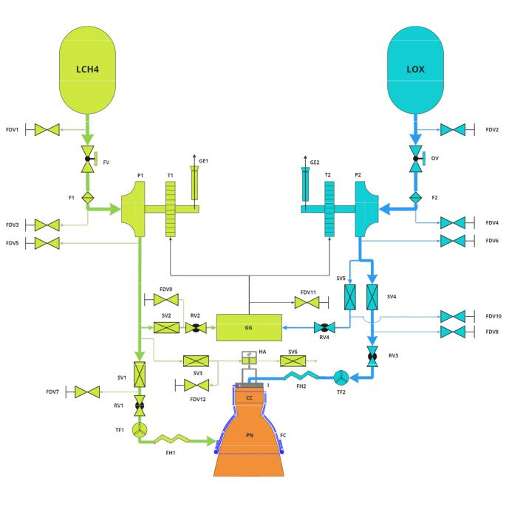

Fig. 3: P&ID schematic diagram.

- Start-up and shut-down sequences

  - Start-up sequence: The start-up of this gas-generator liquid rocket engine – schematically and without exact timings - will be accomplished in the following way: First, the fuel and oxidizer pumps are cooled with LCH4 and LOX respectively by opening the corresponding tank valves FV and OV. This serves to reduce cavitation risk, friction losses and to avoid thermal shock, possibly damaging the engine [chilldown˙just]. FDV1 and FDV2 are kept open during this process as ventilation valves so that any gas, which is possibly produced due to the cooling of the components and the subsequent heating of the fluids, can escape. After

6

TABLE IV: P&ID Legend

Subcomponent | Acronym | Quantity
Fill and Drain Valve | FDV | 12
Fuel Valve | FV | 1
Oxidiser Valve | OV | 1
Filter | F | 2
Pump | P | 2
Solenoid Valve | SV | 6
Regulator Valve | RV | 4
Gas Generator | GG | 1
Turbine | T | 2
Gas Exhaust | GE | 2
Hydraulic Actuator | HA | 1
Turbine Flowmeter | TF | 2
Flexible Hose | FH | 2
Injector | I | 1
Combustion Chamber | CC | 1
Film & Regenerative Cooling | FC | 1
Parabolic Nozzle | PN | 1

sufficient time, the SV1 is opened first to allow for the nozzle to be cooled with the regenerative and film cooling approach used. Shortly after, the SV4 is opened as well. Simultaneously, the mentioned ventilation valves are closed to prevent leakage and the main combustion chamber is then ignited. The latter is done so that the propellant already reaching the combustion chamber is burnt in a controlled manner and so that the combustion can properly build up. At this point, the combustion chamber pressure comes from the difference between tank pressure and ambient pressure, as well as the hydro-static pressure difference between the higher-positioned tanks and the lower chamber. Now, the turbines are started externally with a pyrotechnic charge. This ensures proper pressure increase through the pumps and by that proper combustion under nominal conditions in the main combustion chamber and eventually the gas generator as well. This then finally allows for the main gas generator valves (SV2 and SV5) to be opened, with the pressure at the inlet being now built up so that the gas generator and therefore the turbines can operate without external power input. Lastly, ignition is now initiated also in the gas generator itself. An approximate time interval for this whole process (excluding the chilling in preparation for the start-up) can be roughly estimated to 4 seconds [Transients]. In short, the sequence can be defined as follows:

- Open FV and OV

- Open FDV1 and FDV2

- Close FDV1 and FDV2

- Open SV1

- Open SV4

- Ignite main combustion chamber

- Start turbines with external pyrotechnic charge

- Open SV2 and SV5

- Ignite Gas Generator

- Shut-down sequence: The shut-down sequence of a gas generator rocket engine is less complex [shutdown˙control] than the start-up, and therefore also not as prone to

instabilities, failures and their possibly catastrophic consequences. Oriented at the shut-down process of the Vulcain 2 engine [vulcain˙shutdown], the proposed shut-down method would mostly be a reverse of the start-up sequence: First, the main valves of the gas generator (SV2 and SV5) are closed to stop the pumps and thereby significantly slow down the propellant flow to the main combustion chamber. Next, the main tank valves (FV and OV) are closed. The same logic as for the start-up sequence applies here, meaning the LCH4 valve (FV) is closed only shortly after the LOX one (OV) was to ensure proper nozzle cooling till the end. Ventilation valves are now also opened to prevent any gas build-up from residual fluids and such within the piping and valves.

- Subsystem technologies

  - Tanks: In order to get an estimate of how big the tanks would turn out to be, a small script was set up based on Barlow’s formula, applied to a vertical capsule tank concept [SCP1]. Since this of course does not take into account things such as bearings, valves etc., a “realism” factor had to be added. By comparing results from the script and actual tank concepts, an appropriate value was found to be very roughly 2. (Due to the lack of available data for rocket tanks, spacecraft tanks were mostly used as a reference instead. The empirical factor found here was about 2.5, so under the assumption that with a bigger tank the effects of the mentioned additional weights become proportionally less, it was assumed to be 2). Naturally, this is not a perfect or very precise approach (it has proven to be within the realistic range of the limited available launcher tank data however), but sufficient for the purposes of this function: Since the calculated masses are not re-used for the staging script itself (which works more generally with an assumed structural ratio), and mostly used to get a more clear understanding of the whole concept as well as to get first estimates of the rocket’s overall size, possible errors with these margins can easily be corrected later and have no immediate effect on other design decisions at this stage of the development process. As with all the other MATLAB scripts and functions, it can be found in the digital appendix of this paper. The results from these calculations can be found in Tab. ??.

  - Turbomachinery: The turbopump system consists of mainly four categories of components: The pumps, the turbines, structural components such as bearings, casings, and shafts (connecting the first two), as well as a gas generator with its own combustion chamber, injection system, and so on. A thorough design of that chamber itself is not within the scope of this paper, but according to [GGLOXLCH4] and [Hahn], it is generally reasonable to assume the combustion temperature in the chamber of the gas generator for these purposes to be anywhere between roughly 700-1100 Kelvin, hereby mostly being restricted by material properties [LIM] and influenced by the mixture ratio between oxidizer and

7

fuel. In order to have a more conservative approach for this preliminary design, an OF ratio of 0.27 was chosen and matched with a combustion temperature of 848 Kelvin by using NASA’s CEARUN program. According to the literature [GGLOXLCH4], said OF ratio is on the more conservative (i.e. more fuel-rich) end of the value range for LCH4/LOX gas generators. Correspondingly, a gas generator combustion pressure of 80 bar (i.e. 80% of the main combustion chamber pressure) was selected [Huzel]. Since liquid methane and liquid oxygen have significant differences in their respective densities and therefore also different rotational speed requirements, two possible turbine/pump configurations are generally feasible [Humble]. The first option would be to account for the different speeds by implementing a gearbox between the turbine and one of the pumps. The second option would be to have two separate turbines, one for the LCH4 side and one for the LOX side. Having some of the same main design guidelines in mind that lead already to the decision to choose a gas generator, a serial turbine arrangement was selected to reduce complexity again as well as to increase reliability. Each pump/turbine configuration is therefore placed on its own shaft and with its own distinct rotational velocity. Generally, for this design approach, the method presented in [Humble] was implemented as a MATLAB script to allow for comparison between different inputs and calculation of the desired parameters. In the following, the main steps taken and trade-offs considered (with respect to the sub-components pumps and turbines) will be explained individually.

Pumps: The pumps need to provide the necessary pressure increase to the propellants. This required increase differs between the methane and oxygen pumps, since the former is also used as a cooling liquid, which is connected to (further) pressure losses during that process. Generally, the pressure provided by the pumps must be equal to the desired combustion chamber pressure plus all the losses (taken into account here were losses in piping and valves, injection losses as well as cooling losses on the methane side) minus any advantageous pressures such as tank pressure (chosen pressure here is 5 bar, for reference see [Huzel] and SpaceX’s Starship [starship]) and suction pressure at the inlet of the pump. Suction pressure was assumed to be 0 in order to be conservative about the required pressure increase (generally, an inducer is placed at the inlet of the pump to avoid/mitigate cavitation by providing such pressure). The resulting pressure diagram can be found in Fig. 4, showing how the pressure within the fluid evolves with respect to its flow direction. The complete flow of calculations are explained in detail in the MATLAB implementation. The results of the calculations for the radial pumps can be found in ??. It includes the values for the Net Positive Suction Head (NPSH), which is an indicator for the respective pump’s proneness to cavitation (the higher the value the better) and which proves that for the calculations as performed, this should not pose a significant issue.

Fig. 4: Pressure Profile
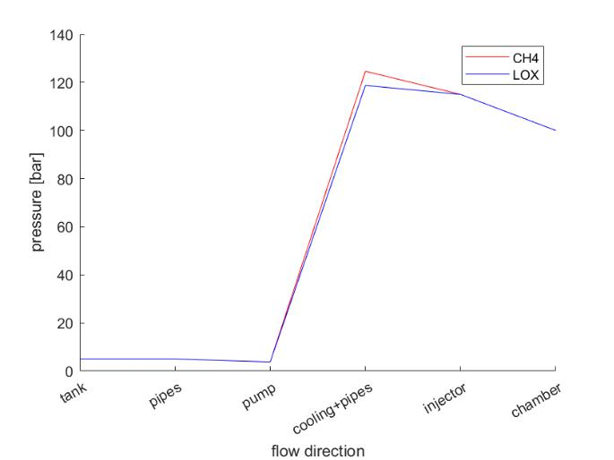

Turbines: The first design decision with respect to the turbines is the distinction between impulse turbines and reaction turbines. Since the mass flow going through the turbines in a gas generator engine cycle can only be expanded separately and thereby has to be considered a loss (or rather a decrease in overall efficiency), it is desirable to keep the turbine mass flow as small as possible. This leads to the obvious decision of choosing an impulse turbine for this type of cycle, with comparatively high contraction ratios (meaning the ratio between the inlet and exit pressures) and therefore smaller flow rates. To be more precise, a two-stage, pressure-compounded turbine - meaning pressure is dropped over two stages - is a reasonable choice in the conceptual design phase for a gas generator cycle engine [Humble] and is therefore the turbine type of choice for this design analysis. As already mentioned, the most important design trade-off for the turbines made was to go for a serial arrangement. This means, however, that the mass flow has to be the same for both, while the contraction ratio may differ. This led to the following approach: A reasonable contraction ratio (maximum 20, [Humble]) is selected as the starting point and used to calculate the required mass flow through the first turbine. This turbine mass flow is then fixed and used to calculate the required contraction ratio for the second turbine. This process is then focused on minimizing the required turbine mass flow under the condition that both contraction ratios have to be below their respective maximums of 20. It also has to be taken into consideration that the final exit pressure after the second turbine should at least be a certain margin over sea-level conditions of one bar to allow for choked flow. For this analysis, it was found to be about 1.8 bars, with additional typical losses and conservative rounding, this comes out to about 2 bar [RP1], which was therefore the design goal for the LCH4 turbine exit pressure (see Tab. ?? for reference). This minimization problem under

8

TABLE V: Turbopumps Overview

 |  |  | Final Values
Mass flow [ | kg | ] | 5:6573
 | s
Combined contraction ratio [-] |  |  | 37:375
System mass [kg] |  |  | 78:875
Adjusted O/F ratio [-] |  |  | 3:7214

constraints was solved in the form of repetitive input/output comparison until a satisfying combination was found that fulfills all boundaries while achieving its goal, i.e. the minimal possible turbine flow under the given constraints (a short overview is presented in Tab. ??. Calculations for both cases - meaning either the methane or the oxygen turbine being placed upstream - have shown that putting the oxidizer turbine first leads to a more favorable combination of said design parameters, meaning that under the given constraints, the required mass flow was higher when the methane turbine was placed upstream of the oxidizer turbine and therefore the opposite arrangement was chosen.

In conclusion, the approach is feasible and leads to rea-sonable results. An empirical correlation [Humble] between thrust and weight was used here for a first estimate of the tur-bopump’s overall system mass. An adjusted oxidizer/fuel ratio is also calculated, since the methane-rich burning process in the gas generator leads to a shift in the O/F ratio reaching the main combustion chamber. These two, together with the results for the most important general design parameters - namely the required turbine mass flow and the overall (=combined) contraction ratio - are presented in Tab. V.

  - Side Nozzle: Since the flow that was branched off through the gas generator and the turbines has already been combusted and due to its vastly different thermodynamic state after the whole process, this mixture cannot be combusted (again) in the main combustion chamber. Nevertheless, it still has some energy stored within it, so just dumping it without any further consideration is also clearly not desirable. Instead, the gas burnt in the gas generator is eventually expanded in a small separate nozzle. While the thrust provided by this evidently is not even close to the one from the main thrust chamber (and not intended to be), it still helps mitigate the losses from the separated turbine mass flow. For this, the MATLAB script for the main nozzle was adapted to provide a quick estimate for the thrust this system can possibly provide. As means of a conservative approach, that thrust however is not taken into account for the overall system performance analysis (also not accounted for is the mass of this comparatively small part). In return, this will provide a

- rather small - performance budget that can counter other misjudgments possibly made during the conceptual phase. For reference, the estimated additional thrust and ISP can be found in Tab. ??.

  - Thrust chamber: The thrust chamber contains two major sections, the combustion chamber, and the exhaust nozzle.

Initially, the combustion chamber must be characterized. The throat area derives from the conservation of mass from knowing the flow is choked at the throat. With this, the diameter is easily calculated. To establish the combustion chamber’s dimensions, gas dynamics, and historical data must be combined. The combustion chamber must be big enough to completely mix, atomize, and burn, but small enough to reduce as much mass as possible. Therefore, the characteristic length of the combustion chamber must be decided. A lower L implies smaller engines (less friction losses), minimizing size and mass without sacrificing combustion efficiency. However, as no experimental observations have been made for our specific engine, observational ranged data are obtained [herbertz2014analysis], [RP2]. As the range of experimental data for the propellant combination LOX/LCH4 lies within [1:13 3:39], a value of L = 1:3 is assumed. It is a conservative value that must be tested but is higher than state-of-the-art propellant combinations. Having determined the throat area and the selected characteristic length, the required combustion chamber volume is uniquely defined.

To design the bell nozzle, parabolic-geometry approximations to the bell-nozzle dimensions must be made:

- Choose the percent bell fraction L_{f} = 0:8. This refers to how much shorter is the parabolic nozzle compared to a conical nozzle with a half angle of 15.

- With the percent bell and the desired expansion ratio, initial _{n} and final _{e} parabola angles can be obtained from Fig. 5.

- Determine the nozzle configuration using basic geome-try.
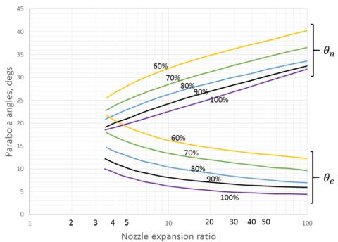

Fig. 5: Initial and final parabolic angles versus desired nozzle expansion ratio.

Taking the above steps, the nozzle contour is calculated in MATLAB and represented in fig: nozzle.

There are a few possibilities when deciding on the design of the thrust chamber: tubular, channel wall, sandwich wall, solid one-piece, or ablative. A solid one-piece is mainly used for low-thrust engines or extension nozzles, while ablative

9

 | 1
 | 0.8
 | 0.6
[m] | 0.4
coordinate | 0.2
Radial | 0
Radial | -0.2
 | -0.4
 | -0.6
 | -0.8
 | -1
 | -0.5 |  | 0 |  | 0.5 |  | 1 |  | 1.5 |  | 2

Length [m]

Fig. 6: Nozzle contour representation.

designs are used for low-thrust engines and reaction control thrusters (RCTs). The other designs - tubular, channel wall, and sandwich wall - vary in complexity, so the choice in design depends on a cost-complexity trade-off and on the country/industry heritage [halchak2018materials]. Often, two or sometimes three different cooling jacket schemes are implemented into the same thrust chamber, making it a relevant consideration to take into account. A channel-wall design is capable of working with high heat transfer while being cheaper and easier to manufacture than a tubular design. However, the resulting engine will be heavier than a tubular design, and thus the Launch Vehicle. For this reason, it’s difficult to tell which option is better from an economical point of view, and an extensive study should be performed in order to decide between both of them. Due to the limited scope of the project and the analysis that can be performed, a channel wall design is chosen for the combustion chamber and the nozzle. This design will consist of a milled channel design. The material used for both the combustion chamber and the nozzle depends upon the design selected. In the case of channel-wall chambers, copper alloys are used generally for the inner liner, and low-alloy steel, stainless steel, or nickel-base materials are used for the outer shell.

Since the thrust chamber will be designed with a channel-wall design, the material for the inner liner will be a copper-chrome-niobium alloy, while the outer shell will be made of a nickel-base material. Some common options of copper alloys to be used for the inner liner of channel-wall designs are NARloy-z, C-18150, and the GRCop-family of alloys developed by NASA. All these alloys have high-thermal conductivity and can withstand high operating temperatures [gradl2019grcop]. The alloy chosen in this case is the GRCop-42. Using a yield strength of 100M P a as the criteria for maximum operating temperature, GRCop-42 is limited to 873K, and its thermal conductivity for this temperature is 335W=(mK) [ellis2003conductivity] [ellis2000thermophysical].

- Cooling system: As it was stated in section 4, in order to choose the cooling approach, an estimate of the heat flux along the thrust chamber was performed. For this purpose, mainly convection heat transfer in the thrust chamber is considered, since it accounts for around 70% or more of the total heat transfer [sutton2016rocket], being the rest heat transfer due to radiation, and the convection coefficient is estimated using Bartz equation [bartz1957simple]. For the combustion chamber, the mean Mach number between inlet and outlet is obtained and the heat transfer coefficient corresponding to that Mach number is assumed constant for the whole chamber.

The thermodynamic properties of the fluid are obtained using the Chemical Equilibrium Application (CEA) software. The hot gas-side wall temperature is assumed to be the maximum operating temperature of the copper alloy being considered (873K for GRCop-42 [gradl2019grcop]). This temperature is assumed constant for the whole thrust chamber as a first estimate. Before digging into the design process for the cooling channels, it is important to set an objective for the design which it is checked later. The main design goal is to keep the wall temperature of the thrust chamber always below the maximum operating temperature of the material of the chamber, which is accomplished by ensuring that the heat transfer in the coolant side is high enough, but another design goal is to keep the outlet temperature below a certain limit. There are limitations to this temperature, such as temperatures that provoke two-phase flow, transcritical flow, or the operational limit of the material used in the cooling channels, among other possible criteria.

Methane operates in the cooling channels of a rocket engine in conditions near the transcritical region; thus, considering the effects of such a flow are crucial for the correct design of the cooling channels. Heat transfer deterioration is a phenomenon that may occur when working with transcritical flows, and it’s crucial in determining it for the design of the engine. When heat transfer deterioration happens, the heat transfer coefficient cannot be modelled with typical empirical correlations, and further analysis must be performed to correctly estimate the heat transfer coefficient. The approach is to design the cooling channels assuming supercritical flow conditions and ignoring the heat deterioration, since modelling it is too complex for the scope of this project; in later phases of the design heat deterioration can be analyzed, and if it takes place, corrections can be made to the design to avoid thermal failure of the thrust chamber.

Therefore, in designing the channel walls of the thrust chamber, it is crucial to determine the hydraulic diameter and the number of channels required. The sizing is based on the conditions in the throat region, which is the most critical due to the highest heat flux caused by convection. To ensure safe operation, the outlet temperature limit is set based on the maximum operating temperature of the GRCop-42 in the cooling channels, with a safety factor

10

of approximately 1.5. Therefore, the imposed limit on the outlet temperature is 582K, assuming a maximum operating temperature of GRCop-42 of 873K. To analyze the system, a one-dimensional balance is utilized, wherein for steady-state operation, the heat flux from convection in the hot gas-side wall is equal to the heat conducted through the wall and convected to the fuel in the cooling channels.

It is important first to consider the temperature evolution of the coolant inside the cooling channels, since this is relevant both for the design of the cooling channels and the injector. In order to do this, a Matlab script is developed in which the thrust chamber is divided in different segment with a finite length for which a one-dimensional energy equilibrium is performed, so that the temperature increase in each segment is calculated from the mass flow, the heat flux, and the heat capacity of the coolant in that segment. Now for the design of the cooling channels, since the heat flux in the throat region has been already estimated, considering the heat transfer by conduction through the wall, it is possible to estimate the temperature of the cool-side wall by applying the Fourier Law.

The thickness of the wall can be estimated considering the compression that the coolant exerts to the thrust chamber, which depends on the pressure difference between the coolant and the chamber pressure. Since the pressure drop in the cooling channels is not yet known, the determination of the chamber wall thickness consists of an iterative process. After iterating, we use a value of 6 bar for the pressure drop in the cooling channels. We apply Barlow’s Formula using the pressure drop in the cooling channels as the pressure difference in the formula, and we get the minimum thickness of the wall to be used.

The thickness of the wall used in this case is 1.5 millimeters, and the conductivity is that corresponding to GRCop-42 for the maximum operating temperature (335W=(mK)). Considering the heat transfer by convection in the cooling channels, it is possible to estimate the necessary convection coefficient for the coolant in the channels. The temperature of the coolant is that corresponding to the throat region. Finally, with the relation between Nusselt number and the convection coefficient together with an appropriate correlation for the Nusselt number, it is possible to estimate the necessary hydraulic diameter of the cooling channels.The temperature of the coolant in the throat section is around 295K; for this temperature, we can assume the methane flow is supercritical (??). A Nusselt number correlation for supercritical flow is used, proposed by Ruan and Meng [ruan2012supercritical].

Once the maximum necessary hydraulic diameter is obtained, the circumference corresponding to the throat region can be divided in different cooling channels in order to obtain the necessary number of them. A separation of 2-3 mm is assumed between the different channels. From
this, the number of cooling channels to be used is estimated. Also, the pressure drop in the cooling channels is estimated. For this purpose, the friction factor is estimated assuming a surface roughness height of 1 micrometer [torres2008heat] [yoon2015experimental]. The final geometrical and operating parameters obtained are summarized in Table VI. It can be seen that the outlet temperature criterion is met, since the value of 409K is lower than the limit imposed of 582K. In Appendix ?? in ?? the configuration of the cooling channels in the throat section is shown. In order to size them, a typical aspect ratio of 2.5 is used [wadel1998comparison].

TABLE VI: Final geometrical and performance parameters for the cooling channels

Parameter | Value
Number of channels [-] | 65
Hydraulic diameter [mm] | 13.5
Thickness of inner wall [mm] | 1.5
Cooling channels roughness height [µm] | 1
Material of inner liner | GRCop-42
Temperature increase [K] | 297.66
Outlet temperature [K] | 409
Pressure drop [bar] | 5.9

Besides regenerative cooling, as it was mentioned in previous sections, film cooling is also used. This is used both in the injection, as it is explained in next section, and also in certain parts along the thrust chamber for which hot spots are detected from CFD and experimental analysis and tests. These analysis and tests are not included in this project because of its limited scope, and are to be done in further phases of the design.

- Injector: After performing the trade-off of the injector, a swirl coaxial injector is chosen. For the design of this engine, a two-phase swirl coaxial injector is used, giving swirl to only the liquid oxidizer. Swirl coaxial injectors are normally used with gas-liquid mixtures, while biswirl coaxial injectors are used with liquid-liquid mixtures [ahn2019experimental]. It is chosen to use a liquid centered swirl coaxial injector, since in this way the gaseous fuel flowing in the outer region of the injector prevents the oxidizer from reaching the wall [jeon2011experimental]. The fuel injected is not really a gas, since it is in a supercritical state, but for the injection conditions it behaves similar to a gas.

For the injector design, one of the first things to determine is the desired pressure drop in it. In order to avoid feed-coupled combustion instabilities, the pressure drop in the injector must be higher than: 30% of chamber pressure for a throttled engine, and 20% if it is unthrottled [Humble]. However, this pressure drop is also dependent on the kind of elements being used. In the case of swirl coaxial injectors, the pressure drop must be at least 8% of chamber pressure to avoid combustion instabilities, but it is typically chosen between 15-20% of the chamber pressure to facilitate the management of pump requirements [ahn2019experimental]. Thus, for this design,

11

the pressure drop in the injector is chosen to be 15% of the chamber pressure. From a performance point of view, it’s interesting to use as many elements in the injector as possible, since reduced diameters of the orifices will mean smaller droplet sizes and higher velocities in injection, which enhances mixing. However, from a complexity point of view, a higher number of elements in the injector means that the manifold will be more difficult to design and manufacture. Thus, a compromise solution is chosen.

To get a first approximation in a preliminary design to the compromise solution, a desired element propellant loading is found, and based on this parameter the number of elements to be used is estimated. The element propellant loading refers to the total mass flow that each element handles in the injector.

In order to find the desired element propellant loading, a look is taken at previous design of rocket engines, and a relation between the thrust and the element propellant loading is found. This relation is almost linear, so based on the expected thrust of the engine the element propellant loading can be derived. For the case of the engine being designed, the desired element propellant loading is of 0.66 kg/s. Now, with the total propellant flow and the element loading, the number of elements is determined (Figure 7).

[kg/s] | 1.6
[kg/s] | 1.4 | R² = 0.9418
loading |  | R² = 0.9418
loading | 1.2
propellant | 1
propellant | 0.8
Element | 0.6
Element | 0.2
 | 0.4
 | 0

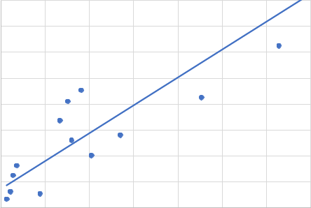
- 500000 1000000 1500000 2000000 2500000 3000000 3500000

Thrust [N]

Fig. 7: Element propellant loading vs thrust of previous engine designs.

With the pressure drop in the injector and the density of fuel and oxidizer, the injection velocity is estimated, and using the continuity equation the total injection area for oxidizer and fuel are estimated. In the determination of the necessary injection area it’s important to account for the discharge coefficient of the injector. This parameter depends on the kind of elements being used. In the case of swirl coaxial elements, this discharge coefficient can be estimated to have a value of 0.3 for the swirling propellant, and of 0.7 for the non-swirling propellant [sutton2016rocket] [ahn2012effects]. A better estimation of the discharge coefficient of the injector comes from performing cold flow tests after the manufacturing of the component.
In order to provide with film cooling capabilities, the elements in the injector are arranged such that the mixture ratio in the center elements is different than the mixture ratio in the outer elements; in fact, outer elements have a richer mixture ratio in order to diminish the temperature near the wall of the combustion chamber.

The main geometrical and operating parameters obtained for the injector are summarized in Table VII. The faceplate of the injector can be seen in Appendix ??, in ??.

TABLE VII: Final geometric and performance parameters for the injector

Parameter | Value
Pressure drop | 15% of chamber pressure
Element propellant | 0.66
loading [kg/s] | 0.66
Number of elements [-] | 594
Diameter oxidizer [mm] | 6.1
Gap width fuel [mm] | 0.66
Injection velocity of | 230.46
fuel [m/s] | 230.46
Injection velocity of | 50.73
oxidizer [m/s] | 50.73

E. Main geometrical Performance parameters

The main geometrical and performance parameters of the engine are shown in Table VIII.

F. Launcher performance & V recalculation

Once the main parameters of the engine are known, a simulation has been performed to verify the launcher’s performance over time. To do so, a MATLAB model has been developed.

The model’s main objective is to obtain the V and other important parameters such as the Thrust or Isp over the burning time. The inputs are the mass of the launcher, the mass flow, the size of the launcher, and the nozzle parameters. For a full explanation of the inputs and outputs, refer directly to the MATLAB script. The model can work with a fixed path angle trajectory or by stating the initial path angle and performing a gravity turn. The path angle optimization required to achieve specific orbits and payloads is out of the scope of this project due to complexity [mota2018trajectory] [bollino2006high]. For the performance example that is shown above, the launcher follows an approximated path angle designed with other launchers’ path trajectory data [doekhie2013computer] [ariane5manual]. For this reason, and in alignment with the rest of the project, a conservative approach is followed, as the launcher performance can be improved using an optimized path angle.

The model solves the EDP of the state of the launcher numerically [curtis2013orbital] for every dt obtaining the performance of the launcher at every time of the burning.

12

TABLE VIII: Main geometrical and performance parameter of the first stage engine

Thrust SL [MN] | Thrust VAC [MN] | Isp SL [s] | Isp VAC[s] | Chamber Pressure [Mpa] | Expansion ratio | O/F | Mass flow [Kg/s] | Exit diameter [m]
1.147 | 1.355 | 291.5 | 344.7 | 100 | 29.4 | 3.5 | 391.95 | 1.62

In this way, the main forces which act over the launcher are computed, obtaining the force in the x-axis of the launcher:
^{F}x ⁼ ^{F}thrust ^{F}grav ^{F}ath.
The F_{thrust} & F_{grav} can be calculated directly from these equations. However, for the calculation of the atmospheric drag, further calculations must be performed. The atmospheric pressure and density are calculated with the ATMOSCOESA [atmoscoesa] model. As it is hypothesized that the lift of the launcher is null, the atmospheric drag would only be caused by static drag. To obtain an approximated static drag coefficient C_{d0}, the equations described in [onel2018drag] have been used. This model discretise the parts of the rocket and computes the C_{d} for each subpart using analytical equations and empirical interpolations of previous studies [stoney1961]. Using this semi-empiric model and the actual size parameters of the launcher, computed previously, the different components of C_{D0} can be calculated. Obtaining
^{C}D;Basedrag^{; C}D;Skinfriction^{; C}D;Bodypressure.
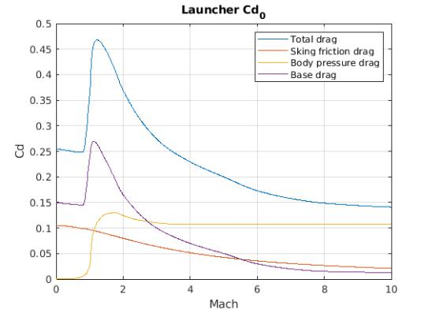

Fig. 8: Static drag coefficient vs Mach Number.

Certain values have been assumed to calculate the static drag. The roughness of the skin has been fixed with a value of 1 m RA, which is a value relatively easy to achieve after a mechanical finish. Another important design parameter is the shape of the fairing. Several shapes have been considered in a trade-off analysis, ??. From this analysis, two shapes have been selected, the LV Haack and the LD Haack [crowell1996descriptive]. Both are in the family of the Haack series and are specifically designed to optimize drag. The LD produces slightly less drag but also has a slightly inferior volume. As the volume difference cannot make a difference in the amount or size of the satellites that can be launched, finally the LD-Haack fairing has been selected.

Once calculated an approximation of the aerodynamics of the launcher, we can finally compute the performance of the

launcher. The engines of the second and third stages have been fixed as a scale reduction of the first stage engine, meaning the proportion of the area parameters are conserved, but the size is reduced. Also, the chamber temperature and pressure are maintained. The scale reduction has been based on the mass flux. As a first approximation, and based on other launchers’ burning time [ariane5manual] [vegamanual], the mass flow of the second stage has been reduced 5 times and the mass flow of the third stage 30 times. Since upper engines only have one engine, this is traduced in a 3/5 and 1/10 scale reduction of the main engine for the second and the third stage respectively.

TABLE IX: Mass flow and Nozzel exit diameter per stage

 | Stage 1 | Stage 2 | Stage 3
Nº engines | 3 | 1 | 1
m [kg/s] | 1175.8 | 235.2 | 39.2
D_{ext} [m] | 1.62 | 0.97 | 0.16

With these mass flows, we can finally compute the performance of the launcher, obtaining:
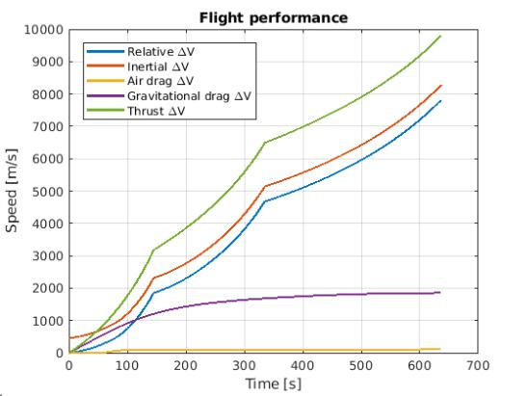

Fig. 9: V performance over time.

In Figure 9 we can observe the model computed V components over time. We can verify that the launcher can successfully complete the required mission. Drag values are in the order of the expected ones, even though gravitational and atmospheric losses can be further improved. These V values are re-introduced in the V budget until convergence, obtaining a final values of:

TABLE X: V contributions [m/s]
^{V}T hrust | Vgrav | ^{V}ath | V_{F}
9797.9 | 1866.13 | 118.46 | 8213.7

This extra V performance is mainly caused by the selection of Isp values during staging (mainly the first stage),

13

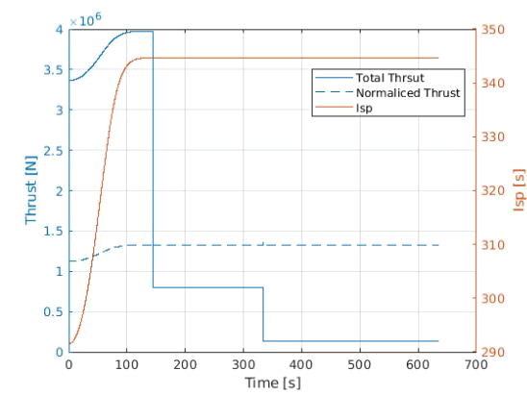

Fig. 10: Thrust and Specific Impulse over time.

in which the Isp changes considerably. For the staging selection, a mean between the bigger and the lower value of the Isp during the first stage has been selected. Adjusting the Isp at this stage, the mass budget and the final V can be lowered. Nevertheless, following the conservative approach and the market analysis, this extra V budget has been maintained to be capable of reaching higher orbit altitudes and inclinations.

In Fig. 10 the thrust and specific impulse change over time is shown. The steps in the thrust correspond to a stage change and the subsequent thrust reduction. In the specific impulse, this change is not perceived as the scaling of the nozzle affects both the thrust and the mass flow equivalently, keeping the specific impulse constant. By the end of the first stage, the atmospheric pressure hardly changes, so the values remain almost constant. The dotted plot corresponds to the thrust of the nozzle normalized as if the scale was the original and only were one engine, helping to have a better overview of the thrust change over time and check the implementation of the scale reduction.
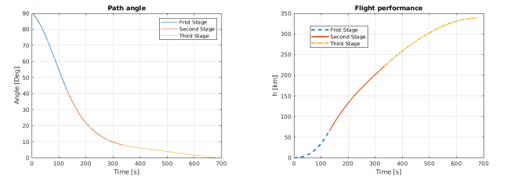

(a) Path angle over time. (b) Height over time.

Fig. 11: Launcher path angle and height

Finally, the launcher’s path and height are presented. Again, it is important to remark that the presented performance is just one mission example and is unoptimized. Note that the height is heavily influenced by the path angle. With adequate path design, several height and velocity pairs can be reached. As a result, a spectrum of different orbits can be obtained,
adapting the injection to the satellite requirements.

Furthermore, the logical continuity would be to design a different upper-stage nozzle, with different dimensions, as the original nozzle is only optimized for the first stage. A change in the fuel composition would also be beneficial. These changes imply the design of a completely new engine, which is out of the scope of the project.

- CONCLUSIONS AND FUTURE DIRECTIONS

Project management and regular meetings have had an incredible impact on the development of the launcher proposal. Weekly meetings have been held in order to track, validate, and re-discuss potential setbacks through the project’s evolution. Interconnectivity between mission design considerations and engine subsystems has made coordination between team members crucial, proving communication a significant role. Targets, deadlines, and Gantt charts have become our best allies.

Due to time constraints, some topics could be further developed in posterior project phases. For example, studying in detail the reusability of the launcher and incorporating a cost-efficient strategy for it; considering new launch sites to be used, which could also be beneficial to target other mission natures; developing detailed engines for the second and third stages of the launcher; continuing with the design phase of the engines in the launcher obtaining better estimates and designs; improving the payload capability of the launcher with a more powerful version of the launcher is something worth considering.

VI. TEAM SETUP

As stated in section V, project management was crucial for achieving the results presented in this document. In the beginning, topics were equally rotated among the members of the team to achieve a solid common ground of knowledge and understanding of the process and thus, divided into focused topics at a later stage with constant peer-to-peer review and participation from all the rest of the team members. Research, scripts and additional material included or used for designing the launcher system has been developed thanks to the coordi-nated participation of all members.

Angel Sosa has been responsible for the selection and trade-off of engine types, cycles, launch site, propellant, the initial mission analysis, and the treatment of the engine key perfor-mance parameters. Anibal Guerrero has been responsible for analyzing the target orbits, payload capability, designing the schematic of the propulsion system, the final launcher design, the nozzle, and geometrical parameters. Alejandro Lopez´ has been responsible for the cooling system, injector, subcompo-nent trade-offs, and geometrical parameters. Christian Racke has been responsible for the general propulsion system archi-tecture and the pumps. Ignacio Zu´niga˜ has been responsible

14

for the launcher V requirements and mass budget, as well as

the V recalculation in a later stage. Although team members

developed areas of expertise, there was an active participation

in other tasks besides the main one. A distribution of the work

load, tasks, and goals can be seen in ??.

VII. INDIVIDUAL PART

Following can be found the individual part.

15

Parts/Anibal

16

A

17

B

18

C

19

